Visionary insect screen roller blinds

Warema introduces highly transparent and tear-resistant "VisionAir" gauze

As of 1 July 2013, the full-range provider for internal and external sun shading systems is offering the "VisionAir" gauze for insect screen roller blinds. The black, highly transparent fabric is available to specialist partners of the company at no extra charge.

The new "VisionAir" gauze provides a better view out and promotes good air circulation in the interior. The fine, plastic-coated fibreglass mesh is extremely tear-resistant and almost invisible from the outside and inside. The fabric can be used in fixed, swivel and sash frames, as well as in the insect screen roller blinds of the sunlight management expert. This effective insect screen is integrated in a wide range of different roller shutter types as well as in front-mounted external venetian blinds, top-mounted external venetian blinds for new buildings, and venetian blind window systems. It can be operated independently of the roller shutter curtain or external venetian blind. In the course of this change, the soft-raise function for gently raising insect screen roller blinds in a controlled manner was revised, which is why the minimum widths of the roller blinds can now be reduced by 50 mm.

Transparency of designs 47008 ("VisionAir" gauze), 47001 and 47000 (from left to right)

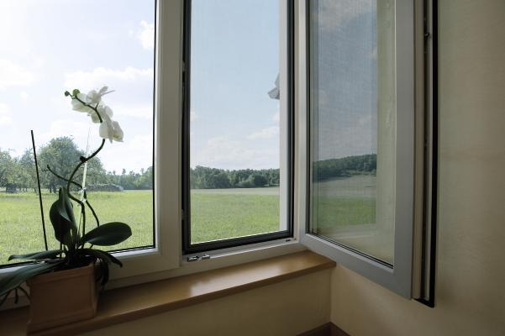
The new "VisionAir" gauze is extremely tear-resistant and almost invisible from the inside.

